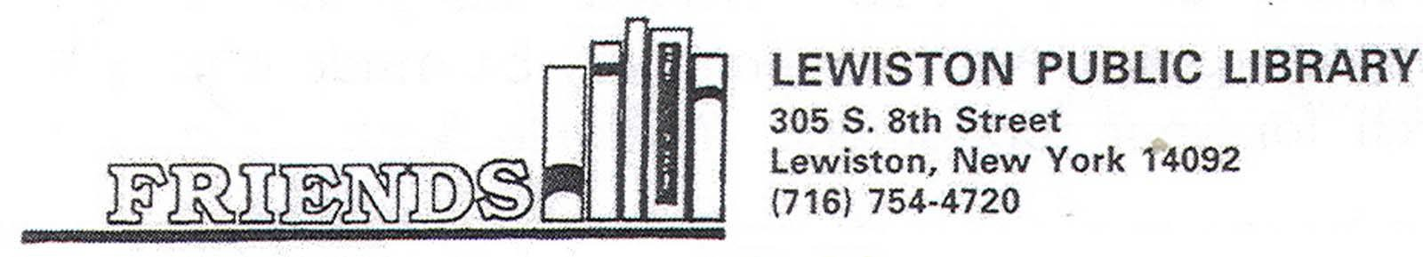

NEWSLETTER October 2023

President’s Message – JoAnne Lotterio

Many thanks for your continuing support. The Friends of the Lewiston Public Library have been able to provide $250,000 plus over the past ten years! We recently purchased new computers for the staff and patrons. A fundraiser to replace literacy stations in the Children’s Room was a great success!
The annual Friendly Gathering is our opportunity to welcome members and the community to the library. Being able to see what a difference your donations make is our goal. As well as meeting our officers, members and library staff.
Last year an award was presented to the Volunteer of the Year. This award is in memory of Mamie Simonson, the true example of what it means to serve your community. The Simonson family generously donated to create a fund to present this award annually. Our Friendly Gathering is the perfect setting. Please join us on November 8th to honor Peggy Salada, this year’s recipient! Music performed by local pianist, Bud Mayer, is a lovely backdrop for this event.
I look forward to celebrating the generosity and hard work of our wonderful Friends of the Lewiston Public Library with you!

MARK YOUR CALENDARS:
FRIENDLY GATHERING – WEDNESDAY, NOVEMBER 8TH @ 6 PM

Volunteer of the Year Award – 2023
By Rita Geiben

The Friends of the Library would like to announce the second recipient for the Volunteer of the Year Award. We are so excited to honor one of Lewiston’s finest volunteers – Peggy Salada.
This program was initiated to honor Mamie Simonson, a wonderful and faithful volunteer for the Friends of the Library. Mamie died in 2016 and is fondly remembered by all of us. Her son, Lee Simonson, generously donated the funds to start the program in memory of his mother. Each year a volunteer is chosen from nominations received and honored at the annual Friendly Gathering. The committee had a very easy task this year in selecting a volunteer to be honored – nominations received for Peggy spoke of her commitment to the library, where she served for many years on the board. Peggy has been involved with the Lewiston Library since 1964, as board president and as an active member of Friends.
Some of the comments about Peggy stated, “Mrs. Salada has been a patron of the Lewiston Public Library for almost 60 years. She has been a board member and Friend of the Library and has shown an unparallel commitment to the library and all of its event.” “Peggy has committed many years of her life and hundreds of hours to our library. Peggy’s passion for the library aligns perfectly with her love of books and reading.” “Peggy has walked Center Street asking for donations. She has volunteered at book sales and other fundraising events. As time goes on, she cannot do all the things she used to, but she still attends the Friend’s meetings when she is able.” The beautiful praises go on and on about Peggy and her dedication to our library. We are thrilled and proud to be able present and honor her at our Friendly Gathering on November 8, 2023 @ 6 pm. Please join us and the families and friends of Peggy Salada as Volunteer of the Year as we celebrate her service to our community Library.

2023 New Life Members

The Friends of the Library would like to send a special thank you to our new life members for 2023. As a life member, you pay a one-time payment of $100 and your name is engraved on a plaque in the library. Our generous community continues to support our library every year which allows for the purchase of new books, reference materials and subsidizes programs including Children’s program throughout the year. Please consider becoming a Life Member when you receive your membership information included in this newsletter.

Thank you and welcome to the to the following Life Members 2023:
Ahlas Famiily
Lynn Beseth
Margaret Biondo
Maureen Finn
Marie G. Smother
Dickie Smothers

An Evening with Dickie and Marie Smothers
By Marcia Halliday

On Wednesday, September 27th, supporters of the Lewiston Library were treated to an evening of fun, laughter and memories as Dick Smothers discussed his life and career, including his wildly popular show, The Smothers Brothers Comedy Hour. “Dickie” was interviewed by his wife, Marie.
The event, at the wonderful Bella Rose Winery in Lewiston, was attended by over 125, who enjoyed a variety of appetizers provided by the Friends of the Lewiston Library – the sponsor of the fund-raising event.
Dick reminisced about “The Smothers Brothers Comedy Hour” beating "Bonanza" in the ratings, just two weeks after the brother’s show premiered. He talked about the origin of the famous saying “Mom Always Liked You Best”; this line was 1st said in the first episode of the Comedy Hour. Dick spoke emotionally about his parents, Ruth, a homemaker, and Thomas B. Smothers, an Army officer who died as a Japanese prisoner of war. Dick shared memories of the many entertainers he met and performed with over the years: Jack Benny and George Burns (who impersonated Dick and his brother Tommy to see what it's like to be brothers on television), George Carlin, The Beatles, Jefferson Airplane, Glenn Campbell, Bette Davis, folksinger Pete Seeger, who appeared in 1967 to sing, as part of an anti-war medley, a song called "Waist Deep in the Big Muddy," an obvious allegory about the Vietnam War and President Johnson. Dick recalled that on their final show receiving a letter from former President Johnson which stated, "It is part of the price of leadership of this great and free nation to be the target of clever satirists. You have given the gift of laughter to our people. May we never grow so somber or self-important that we fail to appreciate the humor in our lives."
The Friends of the Lewiston Library wish to extend our sincere thanks to Dick Smothers and his lovely wife Marie, for their support of the Lewiston Library. We also want to thank Mike Schweitzer, owner of Bella Rose Winery and his wonderful staff; Robert LaDuca for providing beautiful music during the cocktail hour preceding Dickie’s spiel and the many Friends who worked to make the evening a success. And a special thanks to the many supporters of the library.

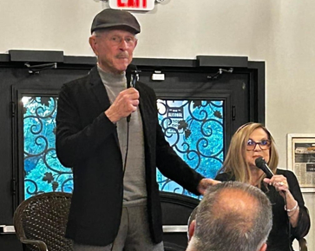

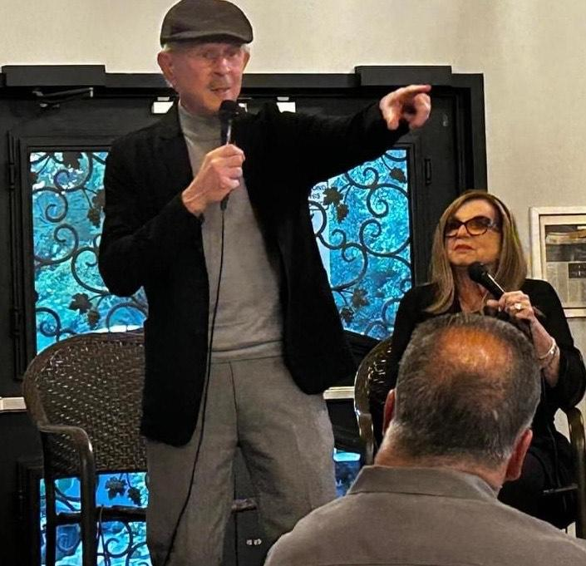

Bon Voyage to Pat and Joe George
By Rita Geiben
The Friends of the Library extend best wishes to Pat and Joe Geoge as they start a new chapter in the book of life in Louisiana to be with their daughter, son in law and grandchildren. Pat served as Vice Preisident of the Friends for many years and her contribtuions to the library is greatly appreicated. We hope Pat and Joe visit Lewiston often and look forward to hearing about their adventures in Louisiana.

Summer Reading Program
By Jill Palermo

Thanks to the support from the Friends of the Library, our “All Together Now” summer reading program was a huge success. Over 1,300 patrons attended the programs that took place over a 6-week period. It was great to see the new faces and families that participated. The Friends sponsored programs by the NYS Parks Department and WAHI Studio and funded the supplies needed for the craft programs such as the very popular tie dye t-shirt making and the rock painting programs. They also funded the weekly giveaways and the end of program grand prize gift cards. The library is thankful for the Friends continued support.

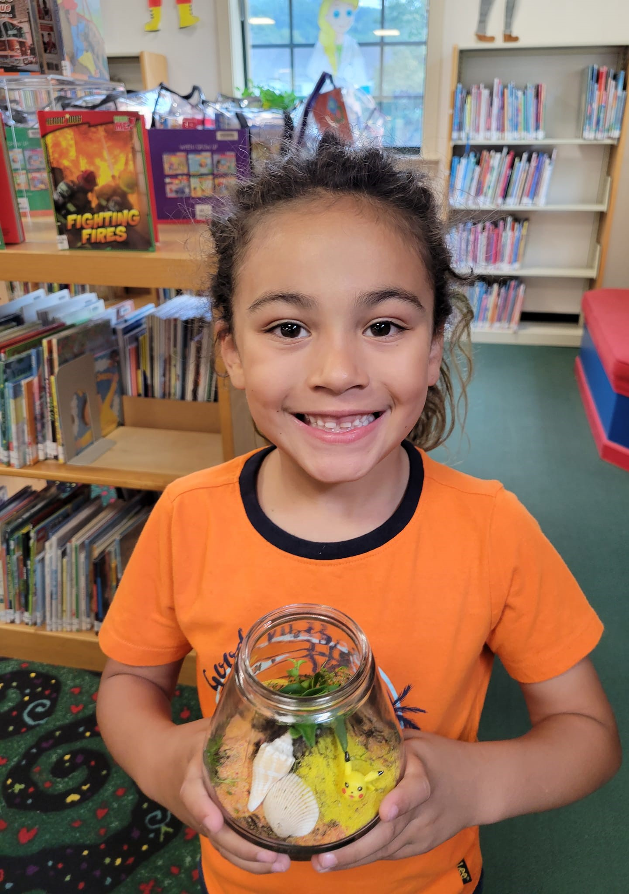
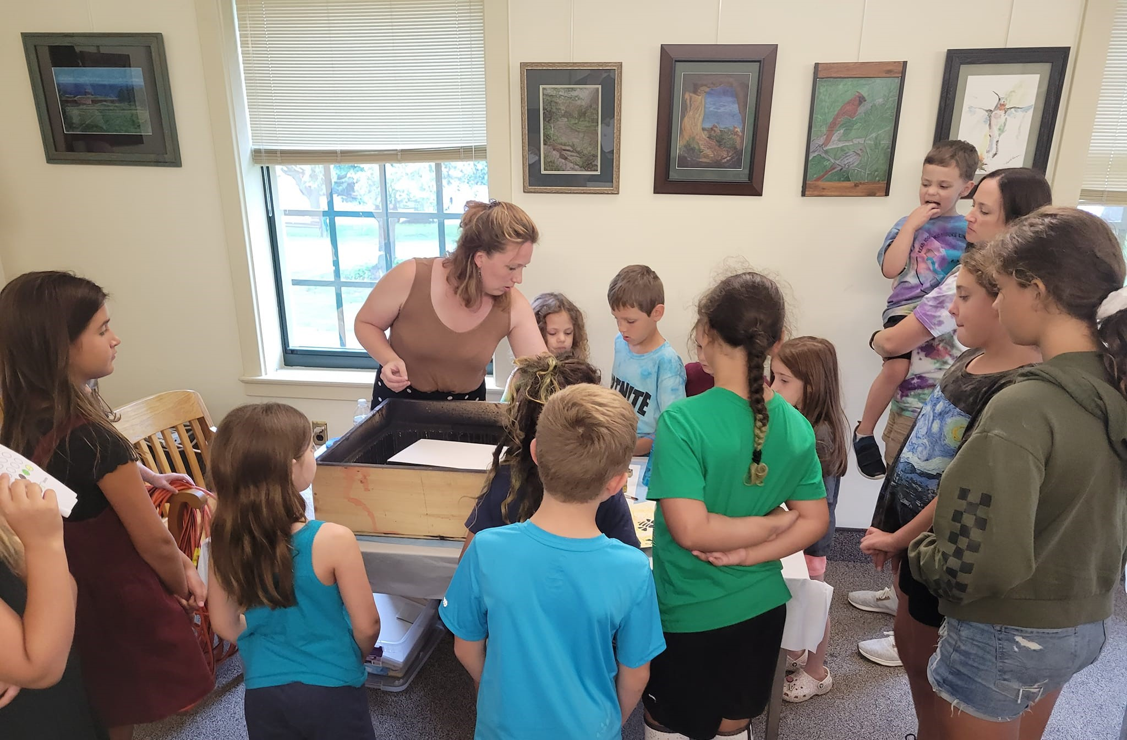
Thank you to Life Members 2023 Donations
The Friends of the Library would like to send a special thank you to all the life members who continue to donate to the library every year. As a life member, you pay a one-time payment of $100 and your name is engraved on a plaque in the library. Our generous community continues to support our library every year which allows for the purchase of new books, reference materials and subsidizes programs including Children’s program throughout the year. Please consider becoming a Life Member when you receive your membership information next February.

Thank you to the following Life Members who donated in 2023:
David and Liz Brooks
John and Beth Ceretto
Judy Condino
Robert and Mary Dutter
Carol Force
William and Rita Geiben
Patricia George
Charles and Linda Hageman
Doris Hampton
Stephen and Karen Lyle
Marion Marcklinger
Nancy Mastrioanni
Michael and Joanne Molnar
Otto and Polly Redanz
Rachel Schebell
Jonathan and Suzanne Schultz
Maureen Weber
Dale Williamson
Sidney and Gayle Walton
Donna Young

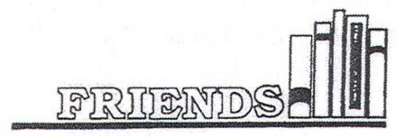

Lewiston Public Library 305 S. 8th Street
Presorted Standard US Postage
PAID
Lewiston, NY Permit No. 144
Lewiston, New York 14092
www.lewistonpubliclibrary.org

